Tórshavn:  Tórshavn is one of the smallest capitals in the world with a population of approx. 18,000. The former municipality of Hoyvík on the picturesque north side of Tórshavn has been incorporated into Thórshavn. A mere half-century ago Tórshavn could only have been considered as a big village, however since that time Tórshavn has changed tremendously. The population has nearly doubled since 1960. The whole of the centre, with the exception of the old Tinganes area, has been modernized and large modern buildings such as schools, colleges, a university, a number of sport facilities, and the SMS shopping mall, a gigantic project by Faroese standards have emerged. In spite of the huge growth and development the Faroes have been through the past two decades, some things remain untouched by modernization, for instance the House of Parliament, a peculiarly unassuming narrow old building from the previous century.  There are two first class hotels in Thórshavn. Hotel Hafnia, which is situated comfortably close to the centre of town, and Hotel Föroyar, located on a hill overlooking Tórshavn with a panoramic view of the town and the neighbouring island, Nólsoy.  Some 250 large and medium-size trading and manufacturing companies are based in Tórshavn, and a sizable industrial centre has been developed in the north-eastern part of the city.  As a national capital, Tórshavn is the centre of cultural activities in the Faroes. It is home to national art galleries and libraries, and also the Nordic House, which has become a cultural centre of great significance for the Faroese people. Designed by architects Ola Steen of Norway and Kolbrún Ragnarsdóttir of Iceland, the Nordic House is widely regarded as one of the finest examples of modern Nordic architecture, and regularly hosts art festivals and serves as a forum for Faroese and inter-Nordic cultural activities. Faroese State Radio, and the Television Service that was only established in 1984, are also located in Tórshavn, and no less than 4 newspapers and several magazines are published in the capital. |  | 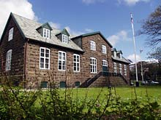  Town Hall of Tórshavn  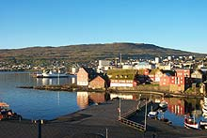  House of Parliament  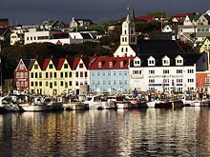  Vágsbotnur in Tórshavn
The Old shop in the heart of Tórshavn  For more than 200 years there have been storehouses at Vágsbotni in Tórshavn and not only has their distinctive look provided the town of Tórshavn with a characteristic and easily recognizable sea front, but their eventful history is closely connected with the culture and traditions which nowadays have made the islands in the North Atlantic so widely known.  Originally the storehouse were built for transit trade and they became an international centere for exotic goods from all over the world that were stored here until they were resold primarily to Great Britain. This trade wich not only made the islands known, but it also meant that many men in this remote country got in touch with a world outside their islands for the first time, and this gave them the courage to fight against the isolation they had endured for ages. Among these was the Faroese champion of liberty.  Nólsoyar Páll (1766-1808) whose statue is placed, most appropriately, right in front of the storehouses at Vágsbotni as if he still telling us that "navigare necesse est". In his satirical ballads he reminds us that, although we are few in numbers compared with the rest of the world, we have no reason to feel shy. Nólsoyar Páll is credited with the achievement of building the ship "Royndin Frída", and although she was lost, the storehouses at Vágsbotni were soon to house a large shipowners's company and shipping business under the management of the famous M.C.Restorff (1816-1897). For his epoch-making and invigorating commercial achievements he was made the first honorary citizen of Tórshavn.  Here many ships from unknown countries anchored and here strange cultures met and foreign languages were heard. This was an El Dorado and a Paradise for any boy fortunate enough to grow up here. The rare and rich history surrounding the storehouses at Vágsbotni also inspired literature and art of international standing such as the world famous writer William Heinesen (1900-1991) and his cousin, Jørgen Frantz jacobsen (1900-1938), who wrote the novel Barbara, . William Heinesen was the managing director of the storehouses at Vágsbotni from 1944 to 53.mkldjklajdjasjklndjdslasdjsalkjdlaskld  The storehouses have been in the same family from 1856 and they are today known as a specialist outlet for Faroese woollen goods such as sweaters knitted in the special Faroese patterns, stockings, mittens, knitted woollen slippers, scarves and caps and, moreover, sailors' clothing, wellingtons, rainwear, working clothes, T-shirts, and enchanting Faroese postcards and souvenirs. |  | 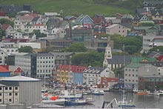  The harbour at Vágsbotn  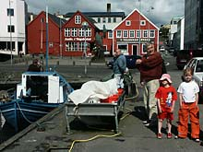  The old shop is the red house to the left, Andr. í Vágsbotni  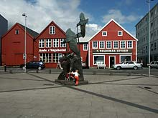  The statue of Nólsoyar Páll
Fort:  The earliest defensive construction was built in Tórshavn at a place called á Ryggi In the 16. century. In 1629. because of a raid on the village of Hvalba (suðuroy) By Turk pirates, the fort was built in the 1630s here at Stangarnes to safeguard the Houses of the Royal Trade Monopoly on Tinganes. In the following years tow Other forts were built, one across Tinganes, Reynaskansi, to defend the Royal Trade Monopoly from land based attacks, and one on the tip of the promontory, Called Lítli Skansi (The Little Fort)  The fort on Stangarnes. Stóri Skansi (The Large Fort). Got its present form in the 1780s after a thorough reconstruction by Captain Born who was commandant of the fort at the time. He 35 or 40 soldiers who manned the fort became a police corps when the fort was dismantled as a military fortification in 1865.  The Fort has four brass guns from the 17. and 18. centuries and tow large guns which were Mounted here during the Second World War when the fort was the headquarters for the British forces in the Faroes. |  | 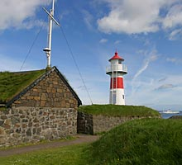
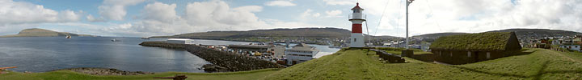

Tinganes  The Faroese parliament, Løgting, is probably the oldest in Europe. On the the historic promontory Tinganes, which divides the capital Torshavn in tow parts, Løgting was founded over a 1000 years ago. The Faroese self-rule is administered by Løgting and the homegoverment, which is appointed by the Løgting. In accordance with nordic parliamentary practices the government represents the political parties that find common ground and have the majority of votes in Løgting. There are 6 political parties, ranging, as regards economic policies, from left to right, and, as regards internal affairs, from those who favour closer ties to Denmark to those who want complete freedom and the establishment of a Faroese republic. The Danish state is represented by an Ombudsman. The Faroese are not a member of the European Common Market. | 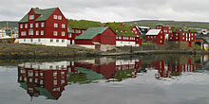  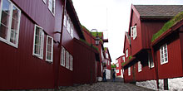
The Birdwatchers Paradise  Binoculars and sunglasses should be part of the outfit of any visitor to the Faroe  Islands. Sunglasses are needed when the brilliant sun bursts forth from the  clouds; binoculars to enjoy the brilliant spectacle of birds soaring along the sea  cliffs.  During the long days of summer, the many cliffs on the northern and western  coasts of the islands teem with huge flocks of birds. Cold arctic currents merge  with the warm Gulf Stream in the waters off the Faroes, resulting in a  particularly rich food environment for the nesting birds.  Ornithologists have identified approximately 300 species of birds in the Faroes.  Of these, 40 species are common breeding birds and about 40 are rare or  irregular visitors.  All have travelled vast distances to raise their families in these remote islands.  The guillemot is one of the first breeding birds to return to the islands, and from  the end of May until the end of July, you can see guillemots up on the cliffs. On  the wider ledges, you can spot the adults standing with their backs to the sea,  protecting the single egg at their feet.  Any tiny projection or bit of rocky outcrop is adequate for the kittiwake to cement  its nest firmly on the cliff. Nesting pairs raise three young ones before leaving  the islands in August.  Colonies of puffins inhabit the ledges and grasslands above the cliffs. You can  spot their breeding areas by the distinctive blue-green colour - the result of  natural fertilizing. To distinguish the puffin from the other birds in the swirling  flocks along the cliffs, look for the small bird flying low above the crests of the  waves, flapping its tiny wings like an overgrown hummingbird.  A bird that nests only on Mykines and Mykinesholm is the gannet. It can be seen  in small flocks diving for food. The island of Nólsoy hosts the largest colony of  storm petrels in the world. A night excursion to witness these nocturnal birds is  an extraordinary experience.  Boat trips to view the various seabird colonies and the soaring sea cliffs around  the Faroes are available. Consult the tourist offices for details. | 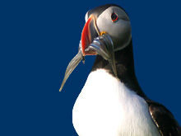  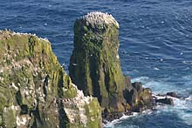  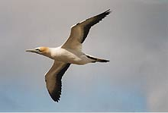
The Faroes Churches  The oldest preserved church in the Faroe Islands is the small parish church of St Olav in Kirkjubøur, built as a part of the Catholic episcopate possibly as early as the 12th century. Yet the grand and majestic ruin of the Magnus Cathedral, started sometime around the beginning of the 14th century, is the foremost historical monument in the Faroe Islands.  It is not these ancient remnants from the Middle Ages, however, that spring to mind when one thinks of Faroese churches. Rather, it is a vision of the black, wooden church with a grass roof that comes to mind. There are many examples of this type of church, all built during a brief 20 year period from around 1830 to 1850. The oldest of these churches is found in Hvalvík on Streymoy and the latest were built in Funningur on Eysturoy and in Porkeri on Suðuroy.  The earliest wooden churches resembled snails snuggled in their shells. In this treeless land, wood was very costly and rare and was used sparingly. Surrounding these very early wooden churches was a protective wall constructed of stones and packed earth. Better times brought changes in church construction and during the course of the 1700s it was common for churches to be built of imported wood and windows were incorporated into the design.  The churches were modest in size, no bigger than other buildings in the village, but the detail work was exquisite. Eventually, a new feature was incorporated into the design: a small, white bell tower, placed either parallel or diagonal to the roof beam.  The inside of these churches is a veritable treasure chest of detailed, unpainted woodwork. The design is humble, yet elegant in its simplicity. The supporting timbers and joists are exposed. Each detail in the design reveals a distinctive profile or bears a special carving. One can almost hear the heavenly music intoned by this beautiful carving.  Many of the newer churches have been inspired by designs found outside the Faroes. Many are quite beautiful and worthy of a visit, especially Christianskirkjan in Klaksvík, Fríðrikskirkjan in Toftir, and the new church in the village of Gøta. They are large and spacious, as the population is now much larger and times have changed, of course. If you desire, however, to gain an appreciation and understanding of the deep spiritual devotion and modesty of the Faroese, you must, without a doubt, visit the old wooden village churches. | 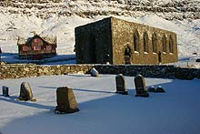  Magnus Cathedral in Kirkjubøur  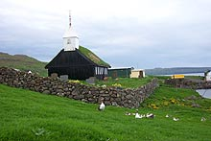  Church in kaldbak  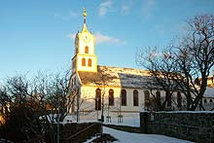  The cathedral in Tórshavn, Havnar Kirkja  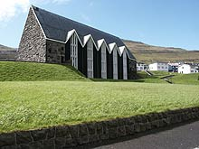  Christianskirkjan in Klaksvík
St. Olav's Day and the Summer Festivals  Before the Reformation the Walke of  St. Olav was an important religious festival in Norway and the Norwegian tributary countries, of wich the Faroes were one.  The Norwegian king Olav the holy fell on the 29th of July, 1030 in the battle at Stiklestad, and every year on that day Norway's patron  saint was commemorated.  It is now a thousand years since the chief Sigmund Brestisson introduced Christianity in a proclamation on the rocky headland at the end of Tinganes in Tórshavn.  The Icelandic saga, Færeyingasaga, decribe the heathen chief Tróndur is in power but, with the help of King Olav Trygvason in Norway, Sigmund defeats his enemy for a time, until he is attacked at his farm on Skúvoy. Sigmund has jump into the sea and swim the long way to Suduroy, where he is found exhausted on the beach and killed by the farmer Tórgrímur the Wicked.  But Christianity triumphed, and Olav the Holy also became the patron saint of the Faroes. In most places he has been forgotten and now only figures in books about Norwegian an Nordic history; but in the Faroes he was so revered that to this day his wake is celebrated in the capital of the island - the Olai Festival. For hundreds of years and despite the fall of Catholicism, this day has been celebrated as a kind of national festival, when work stopped and people flocked to Tórshavn from all over the islands.  Over the years the festival has grown and in order to accommodate all the activities on the programme it now starts on the eve of Saint Olav's Day. On the afternoon of 28th the festival is officially opend with a procession through the town headed by men on horseback with the Faroese flag at the forefront. They make their way to the lawn in front of the parliament building. After this comes the eagerly awaited boat race where the final result of the summer's competitions will be decided and the champions of the year celebrated.  Sporting events, meetings, concerts follow in a tightly packed few can take part in everything. On the other hand, the item witch gives the greatest pleasure is not mentioned in the programme. It is to walk up and down the main street and follow along with the stream of people dressed in their best, often national dress, or to struggle against the stream and greet friends and acquaintances and people you have not seen for years, but who have now come home on holiday, or on a visit, to take part in the festivities.  On the 29th, Saint Olav's Day itself, there is a ceremonial procession from the centre of the town on the church service in the Cathedral. The members of parliament, the government, the clergy and all the leading civill servants take part. After the church service they go back to the parliament buillding, where a choir sing outside. They then enter the prime minister delivers his opening speech. A new political and parliamentary year commences.  Friendships are made or renewed, the whole town town is alive, and there is dancing both outdoors and indoors. And at midnight on the 29th it is over. Then everyone gathers for the community singing in the centre of the town, the streets are full of people, no matter what the weather, and everyone joins in the singing. It is a manifestation of fellowship, the like of which is not seen many places in the world and all the while the colored lamps twinkle in the darkness, which has returned and tells that the festival is over and summer is waning.  Life was often hard in the Faroes, with heavy work in the fields and at sea, and there were constant dangers from fog, storms and lashing seas. This bred a deep sense of religion, which is still characteristic of daily life in the Faroes and which creates a bond far back in time, right back to when Christianity came to the islands.  The summer festivals are the light side of this deep seriousness. The worship of God is a part of them. but it is primarily the festivals and the joy of living that dominate. And the joy of summer's overwhelming light in the world.  Source: Tourist Guide 2002 | 